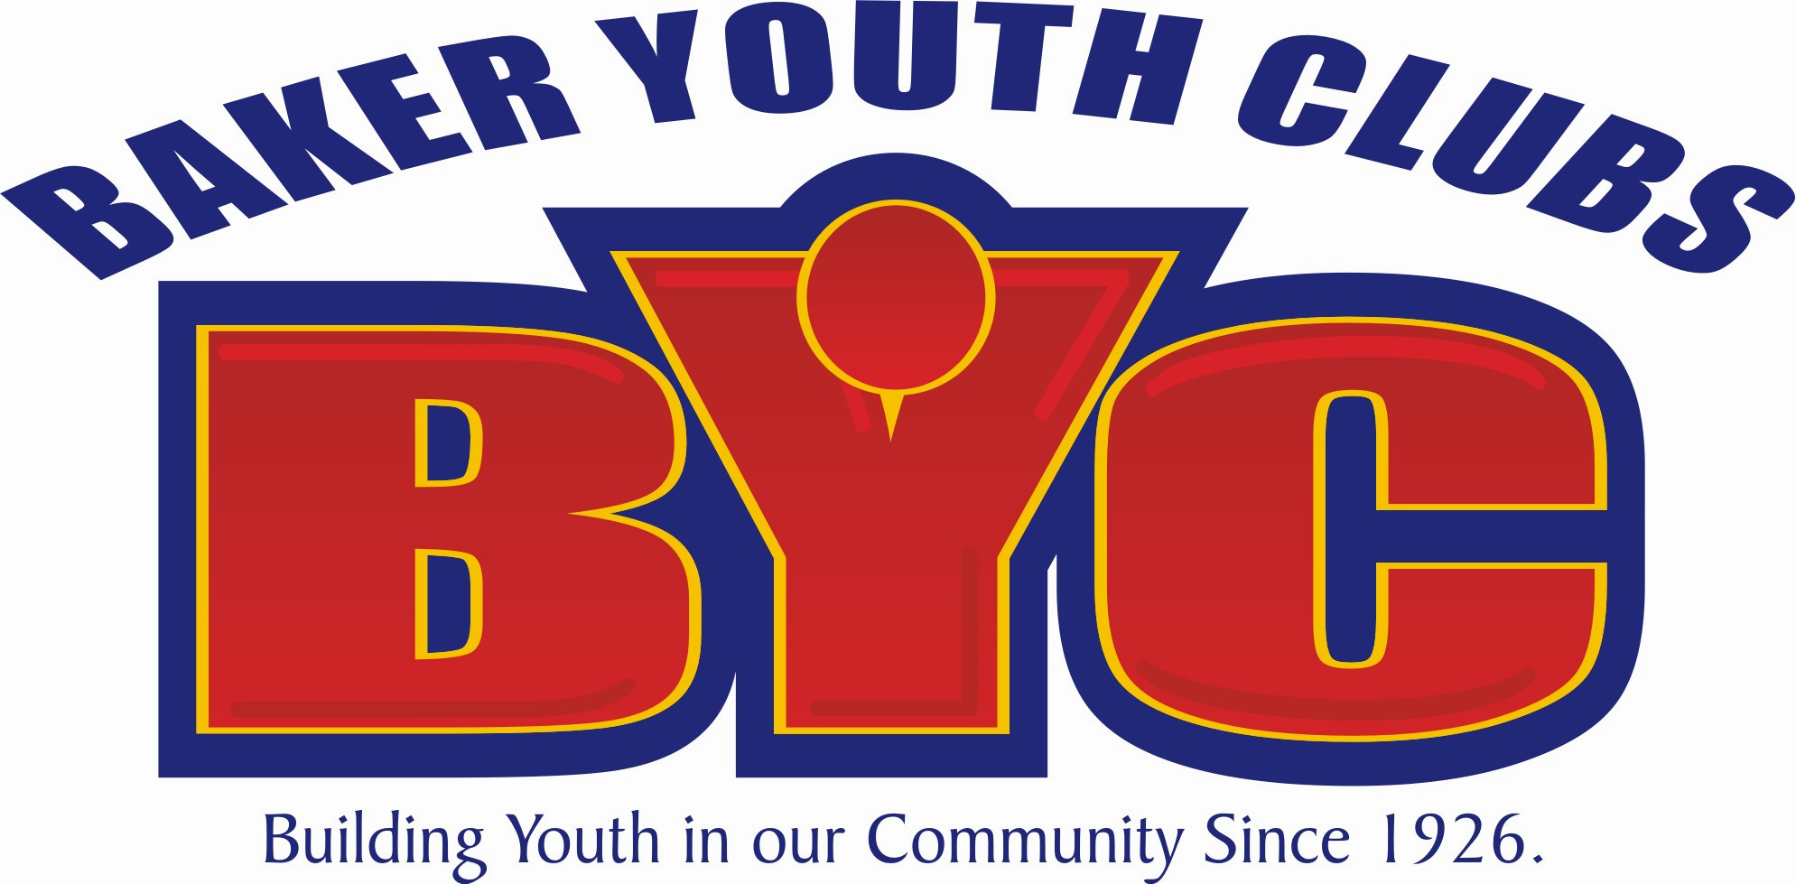

BYC
Summer Program Field Trips

I, ______________________ (parent’s name) give permission for my child______________________ (child’s name) to participate in the following field trips and understand they will be traveling by vehicle to and from BYC. I release Baker Youth Clubs, its employees or volunteers from any liability or responsibility regarding my child. I also give Baker Youth Clubs permission to have my child treated at a medical facility in case of accident, illness or injury. Please put a check mark by EACH field trip that you want your child to participate in.

___ June 14th – Football Field 2:00-3:30pm

___ June 19th^{st} – Deb Collier Dance 2:00-3:30pm

___ June29th - Bowling 2:00-4:00pm

___ July 13th - Skating 2:00-4:00pm

___ TBD –Water Day at Winona Lake 2:00-4:00pm

Signed________________________ (Parent’s Signature) ______________ (Date)

You must also provide the following information:

Phone Number___________________ (this MUST be filled in-even if it’s a neighbor)
Emergency #_____________________
Doctor’s name: ___________________ Doctor’s phone#_______________________

If you have any questions, please contact Caleb Rovenstine, BYC Program Director at 574-267-8771.

